Policy for Escalating ECTs not meeting Teacher’s Standards

2025-2026

Introduction

The aim of ECT induction is to provide targeted support, aligning with the Early Career Framework (ECF), promoting continuous improvement, and ensuring that the ECT has the necessary resources for success. In employing an ECT, schools are committing to support, train and develop the ECT to meet the Teacher’s Standards. Regular and effective communication and collaboration among all stakeholders is essential throughout the process. As soon as a concern is raised the school should contact and inform the Appropriate Body (AB).

An ECT has only one chance to complete statutory induction. An ECT who has completed induction and is judged to have failed to meet the Teachers’ Standards at the end of their induction period, is not permitted to repeat induction. While such an ECT does not lose their QTS, they cannot be employed lawfully as a teacher in a relevant school, including any post where they would carry out specified work.

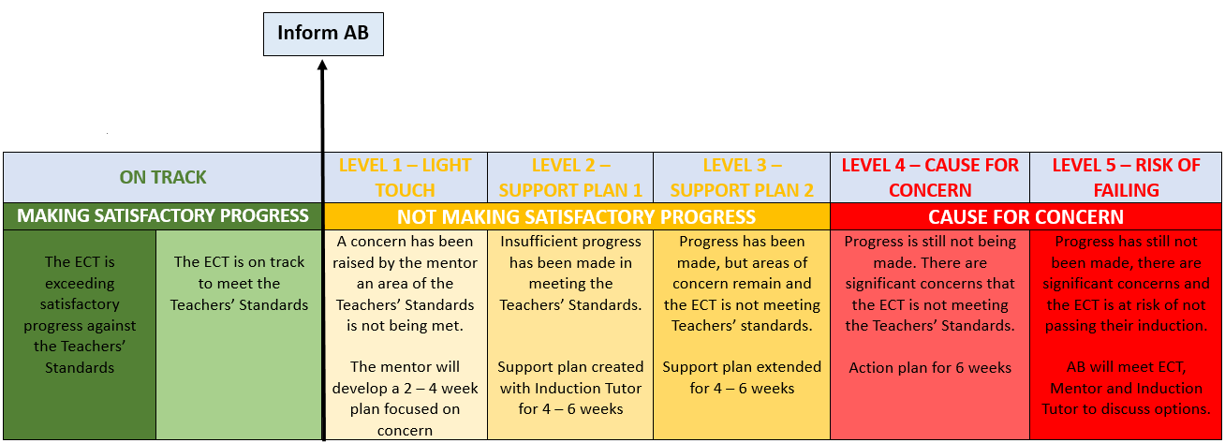
*please note an ECT can be determined as not on track at all Progress Review Points and the first formal assessment. The judgement as to whether ‘the ECT has made satisfactory/unsatisfactory progress within the induction period’ are made at the second/final assessment. For further information please see the Statutory Information.

The ECT is evaluated by the school against the Teachers’ Standards. Once an ECT has been on a Cause for Concern, rigorous monitoring and support must remain in place. The Appropriate Body’s role is to be fair and objective and ensure that the ECT is receiving the support they need to be successful in their induction.

Most importantly the aim of the support plan is to provide extra support to help the ECT get back on track to meet the Teachers’ Standards and not a capability plan.

Level 1 – Light Touch

If a concern has been raised up by the mentor, the mentor will discuss this with the Induction Tutor, but at this point it will be in the hands of the mentor. The mentor should seek advice from the specialists in their school if they lack confidence to develop an effective plan.

Actions:
- Mentor meets with the ECT to clearly communicate concerns.
- Mentor develops a 2 - 4 week plan (seek advice from specialists as appropriate) focusing on a key area for improvement.
- Mentor sets clear targets, outlines steps to achieve them, and defines success criteria.
- Ensure the plan aligns with the Early Career Framework (ECF) and incorporate supporting CPD, for example school focuses, i.e. walkthrus.
- Mentor to support ECT in planning observations of expert teachers to highlight good practice linked to concerns.
- Mentor to have weekly discussions with the ECT to monitor progress and tweak the plan as necessary to support progress.
- Update the AB

Level 2 – Support Plan 1

If no progress has been made step up to Induction Tutor. Induction Tutor informs AB. AB contacts ECT to check ECT is clear on the reasons for not meeting the Teacher’s Standards and to confirm the level of support.

Actions:
- Induction Tutor meets with the ECT to discuss concerns and targets.
- Induction Tutor and mentor develop a 4 - 6 week plan focusing on Teacher's Standards not met. Seek guidance from Head of Department or other specialists, i.e. SENDCo where appropriate.
- Set clear targets, outline steps to achieve them, and clearly define success criteria.
- Aligns the plan with the ECF and other CPD.
- Plans joint observation of good practice with opportunities for narration and discussion of the practice seen.
- Weekly discussions with the ECT to monitor progress (IT may want to meet instead of mentor).
- Update the AB

Level 3 – Support Plan 2

If some progress has been made, but there are still some areas of concern, then a further support plan should be put in place. If this is an ECT1 then extending support plans to accelerate progress can be repeated further. If this is an ECT2 with less time less, it may be better to escalate quicker to support them in not failing their induction.

Actions:
- If concerns persist after Support Plan 1, Induction Tutor to contact the AB, and a meeting with the AB, IT and ECT to be arranged as appropriate.
- Induction Tutor develops an extended 4 - 6 week plan with additional support measures. This may include visiting another school to gain specific observations.
- Ensure all plans align with the ECF and CPD to support the ECT.
- Update the AB

Level 4 – Cause for concern

If progress is still not being made, then the level will be raised. Induction Tutor to contact AB and organise a meeting with AB, IT, Mentor and ECT to discuss options for the ECT. AB could observe and quality assure the observation process to ensure consistency of judgements.

Actions:
- AB meets with the ECT, Mentor, and Induction Tutor to address ongoing concerns.
- Together reviews progress and discusses potential interventions.
- Create a 6 week action plan to clearly outline what ECT needs to do to meet the Teacher’s Standards and monitor weekly.
- Induction Tutor to update AB weekly.

Level 5 – At risk of failing

This stage is likely to be an ECT 2 who is closer to the end of the induction period. If there are significant reasons why the ECT is failing, for example illness, lack of prior support etc. then it may be a point to discuss extending the ECTs Induction.

Actions:
- If the ECT is at risk of failing, AB meets with the ECT, Induction Tutor, and Mentor to discuss the options, which could include but not limited to pausing induction, ECT moving to a new school, Induction extension or rigorous support plan.
- Together develop a comprehensive plan to address specific concerns and challenges.
- Explore additional support measures and interventions.
- Induction Tutor to update the AB weekly

Level 6 – School Capability Procedures

This should be an absolute last resort, but the guidance states:

“In a few particularly serious cases it may be necessary to instigate capability procedures at a stage before the end of the induction period, which may lead to dismissal before the end of the induction period. If this is the case, for as long as the ECT remains at the institution the induction process must continue in parallel with the capability procedure. The appropriate body should be informed.
Dismissal on the grounds of capability before the end of the induction period does not prevent the ECT from completing induction at another institution, as all ECTs must complete a full induction period before they can be judged to have failed induction.”

Actions:
- In serious cases, initiate capability procedures according to the school’s HR policies.
- Continue the induction process in parallel with the capability procedure.
- Inform the appropriate body.

HR v ECT Induction
All organistations have their own policies and processes relating to HR, the below table is an example of the way in which HR processes work alongside the ECT induction. This may not match your school HR processes, but will give you an idea of what needs to be done if there is a concern with the ECT.
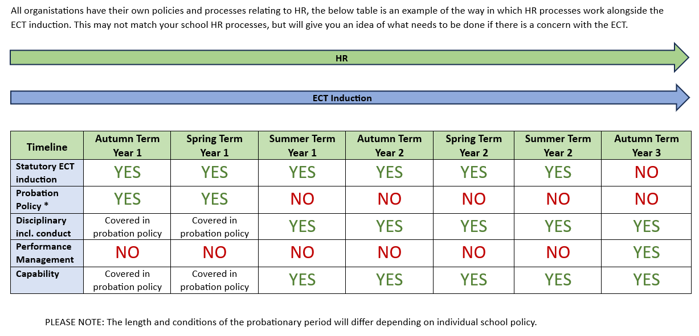

Conclusion

This escalation policy is designed to provide a structured and supportive framework for addressing concerns regarding ECTs not meeting Teacher's Standards. However, ECT situations may differ and as such it is important to keep transparent and open dialogue with the ECT and AB to ensure the best fit for the individual. Regular communication, collaboration, and using the Early Career Framework are key components of this process. Ultimately the aim is to facilitate the professional growth and success of the ECT while maintaining the integrity of the induction process. It is an important aspect of the ECT Induction to retain teachers in the profession and train them to be high quality practitioners.

Raising concerns
Where to direct your concern:

Is your complaint about the service you are receiving from the Appropriate Body?
Is your complaint with the school where you are completing your induction?

Follow the AB complaints policy which is located on our Teaching School Hub website.
Follow the steps in line with your school’s complaints policy or whistle blowing policy depending on the nature of your complaint.
If this does not resolve your complaint, please contact the Appropriate Body for next steps.

Changes to Progress Reviews:

Progress reviews are check ins, designed to ensure that ECTs have opportunities to be regularly assessed so that there are no surprises at the end of the year. Part-time ECTs will still be required to have a progress review completed termly.

From September 2025 progress reviews will no longer require a written report in the case of ECTs on track. Instead, you will be required to only rate each of the Teachers’ Standards as follows:

Exemplary | The ECT consistently exceeds the expectations at this stage of induction. They demonstrate high levels of skill, initiative, and reflective practice, with clear evidence of impact on pupil progress and classroom practice. They are performing at a level well above what is typically expected at this point.
Strong | The ECT is securely meeting all expectations and in some areas, exceeding them. They demonstrate confidence, consistency, and growing independence in their practice. There is clear evidence of effective teaching and positive impact on pupil outcomes.
Secure | The ECT is meeting the expected standards for their stage of induction. They are making steady progress. While there may be areas for continued development, they are on track to successfully complete their induction.
Attention needed | The ECT is making some progress, but there are areas where improvement is required to meet the expected standards. Targeted support and monitoring are needed to help them stay on track. Concerns may be emerging but are not yet critical.
Cause for concern | The ECT is not currently meeting the expectations, and there are significant concerns about their progress. Without immediate and sustained improvement, they may be at risk of not successfully completing their induction. A formal support plan should be considered or already in place.

For those that are ‘Attention needed’ or ‘Cause for Concern’ in any Teacher Standard will require a written statement to outline the areas of concern.

All progress reports will still require targets to be included.

Appendices
- Forms
- Level 1 – Light Touch Support
- Level 2 – Support Plan 1
- Level 3 – Support Plan 2
- Level 4 – Cause for Concern
- Level 5 – Risk of failing

Level 1 – Light Touch Support Mentor:
Date of meeting:
Previous objectives |  | Evaluation of progress
Related Teachers’ Standards: |  | Reason for light touch support:
Objective (linked to Teachers’ Standards) | Success Criteria | Actions to be taken, and by whom: | Resources/support required: | Outcome from observation:

Evaluation of progress: |  | Next Objectives:
End of Light Touch Support Date: |  | Is the ECT on track at end date? | Yes No
Induction Tutor signature: |  | ECT signature:

Level 2 – Support Plan 1
School |  | Dates of plan
ECT |  | Term
Objectives (linked to Teachers’ Standards)

Week | Action/to be taken and by whom. | Resources required (including use of PD time/support provided) | Success Criteria | Evaluation of progress
1
1 | ECTs comment on progress:
2
2 | ECTs comment on progress:
3
3 | ECTs comment on progress:
4
4 | ECTs comment on progress:
5
5 | ECTs comment on progress:
6
6 | ECTs comment on progress:

Evaluation of progress: |  | Next Objectives:
End of Support Plan Date: |  | Is the ECT on track at end date? | Yes No
Induction Tutor signature: |  | ECT signature:

Level 3 – Support Plan 2
School |  | Dates of plan
ECT |  | Term
Objectives (linked to Teachers’ Standards)

Week | Action/to be taken and by whom. | Resources required (including use of PD time/support provided) | Success Criteria | Evaluation of progress
1
1 | ECTs comment on progress:
2
2 | ECTs comment on progress:
3
3 | ECTs comment on progress:
4
4 | ECTs comment on progress:
5
5 | ECTs comment on progress:
6
6 | ECTs comment on progress:

Evaluation of progress: |  | Next Objectives:
End of Support Plan Date: |  | Is the ECT on track at end date? | Yes No
Induction Tutor signature: |  | ECT signature:

Level 4 – Cause for Concern
School |  | Dates of plan
ECT |  | Term
Objectives (linked to Teachers’ Standards)

Week | Action/to be taken and by whom. | Resources required (including use of PD time/support provided) | Success Criteria | Evaluation of progress
1
1 | ECTs comment on progress:
2
2 | ECTs comment on progress:
3
3 | ECTs comment on progress:
4
4 | ECTs comment on progress:
5
5 | ECTs comment on progress:
6
6 | ECTs comment on progress:

Date of meeting with AB, ECT, Mentor and Induction Tutor
Outline of meeting: | Outcome:

Evaluation of progress: |  | Next Objectives:
End of Support Plan Date: |  | Is the ECT on track at end date? | Yes No
Induction Tutor signature: |  | ECT signature:

Level 5 – Risk of Failing
School |  | Dates of plan
ECT |  | Term
Reasons for risk of failing (linked to standards):

Possible reasons for extension to induction:

Week | Action/to be taken and by whom. | Resources required (including use of PD time/support provided) | Success Criteria | Evaluation of progress
1
1 | ECTs comment on progress:
2
2 | ECTs comment on progress:
3
3 | ECTs comment on progress:
4
4 | ECTs comment on progress:
5
5 | ECTs comment on progress:
6

6 | ECTs comment on progress:

Date of meeting with AB, ECT, Mentor and Induction Tutor
Outline of meeting: | Outcome:

Evaluation of progress: |  | Next Objectives:
End of Support Plan Date: |  | Is the ECT on track at end date? | Yes No
Induction Tutor signature: |  | ECT signature:

